MDO project
Jungwook Shin
Paper 1: Efficient sizing and optimization of multirotor drones based on scaling laws and similarity models
The core of this paper is to mathematically approximate the parameters of airframes of various sizes and purposes using only a small amount of reference model data by utilizing 'Scaling Laws'.
This allows for the acquisition of formulas for calculating system parameters (motor specifications, structural design, mass, and dynamic parameters) that are directly necessary for setting the objective function and constraints of MDO projects.
1. Mass
Appendix B.6 and C.5 of this paper present methods for parameterizing the total mass of the airframe and the battery mass.
Total Mass: The total mass of the airframe (M_tot) is defined by summing the masses of each key component based on the number of propellers (N_pro) and the number of arms (N_arm).
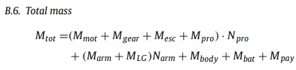
Battery Mass: Calculated by scaling relative to the reference battery model based on the required voltage and capacity.
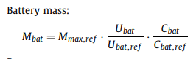

2. Motor Specifications
Appendix C.2 formulates how the motor's mass and dynamic characteristics (moment of inertia) change according to the required torque. These formulas play a key role in simplifying and calculating the dynamic parameters (MOI) required for control simulations.
• Motor Mass: Increases proportionally to the 3/3.5 power of the ratio of the required torque (T_mot) to the reference torque (T_mot,ref).
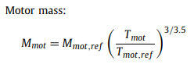
Motor Inertia: The motor inertia (J_{mot}), which is essential for rotational dynamics simulation, is also scaled based on the required torque.
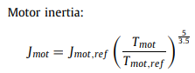
3. Major Structural Design (Structure and Arm Length)
Appendix C.6 defines the minimum length and mass of the arm based on geometric constraints and structural limits.
Minimum Arm Length: To avoid physical interference between propellers, the minimum arm length is set as a constraint based on the propeller diameter (D_pro) and the number of arms (n_arm).
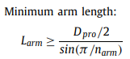
Arm Mass: When using a circular hollow section, the arm mass is derived using the outer diameter (D_out) and the inner-outer diameter ratio (k_frame) as variables.

Paper 2: A BI-LEVEL CO-DESIGN APPROACH FOR MULTICOPTERS
1. Objective Function
This paper clearly formulates and presents the objective function of the outer loop for plant design optimization.
Citation of the original paper:
"1. The system design optimization loop: the outer optimization loop is described by problem 2. This optimization problem aims to minimize the energy consumed (or the total mass of the multicopter) with respect to the design variables defined in table 1 under motor, rotor, battery and arm constraints."
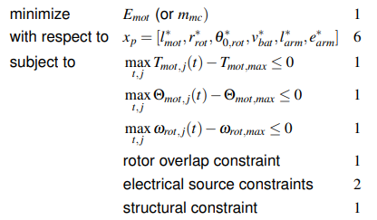
• This paper sets the objective function as minimizing the 'total energy consumed (E_mot)' or the 'total mass of the airframe (m_mc)' when a multicopter performs a specific mission.
• In the ongoing MDO project (Option 1), a more compelling optimization model can be constructed by including not only the trajectory error calculated through simulation, but also the total energy consumed by the motors or the mass of the airframe in the objective function (Cost function).
2. Design Variables
Since the paper uses a bi-level structure that simultaneously optimizes hardware (Plant) and software (Control), the design variables are also specified as being divided into two categories.
A. Plant Design Variables
"The main subsystems (motor, rotor, battery and arm) are designed through six design variables: the size of the motor, the rotor radius, the pitch rotor, the battery size, the arm length and the arm thickness, see figure 6. They are respectively stored in the vector of the plant design variables (x_{p}), see equation 1."
:
• We established motor size (l_mot), rotor radius (r_rot), rotor pitch (theta_{0,rot}), battery size (v_{bat}), arm length (l_{arm}), and arm thickness (e_{arm}) as the six major variables determining the hardware.
Major structural design: We structured arm length into a normalized variable form and utilized it for optimization.
B. Control Design Variables
"Position and attitude control are both composed of three simple proportional controllers... The velocity and angular rate controllers are both composed of three simple proportional integral controllers. ... Therefore a total of 16 control gains must be tuned..."
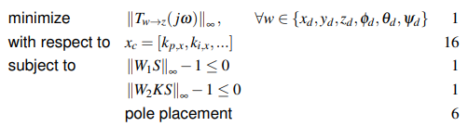
• In the control loop, P (Proportional) and PI (Proportional-Integral) controllers were configured to control position, attitude, velocity, and angular velocity, and a total of 16 control gains were set as design variables (x_{c}) to be tuned.

• This corresponds to the "Gain: feasible gain" section of the proposal; it serves as a reference for setting these control gains as optimization variables to reduce trajectory tracking errors within the dynamic simulation.

Fault situation: Complete failure of a single rotor during hovering

This is the most intuitive and widely used scenario, capable of clearly demonstrating the controller's failure recovery capability.

o In this paper, a scenario was established where the first rotor fails at the 3-second mark in a simulation environment where the aircraft maintains hovering.
o Immediately after the failure occurs, the rotational speed of the corresponding rotor (Rotor 1) is forcibly dropped to zero. o At this time, the controller intentionally slows down the rotor located on the exact opposite side of the faulty rotor (rotor number 7 in the octocopter of this paper) to balance the three-dimensional moment of the airframe.
o Consequently, to compensate for the reduced total thrust and overcome gravity, the remaining normal rotors are induced to produce a higher thrust than before the failure.

